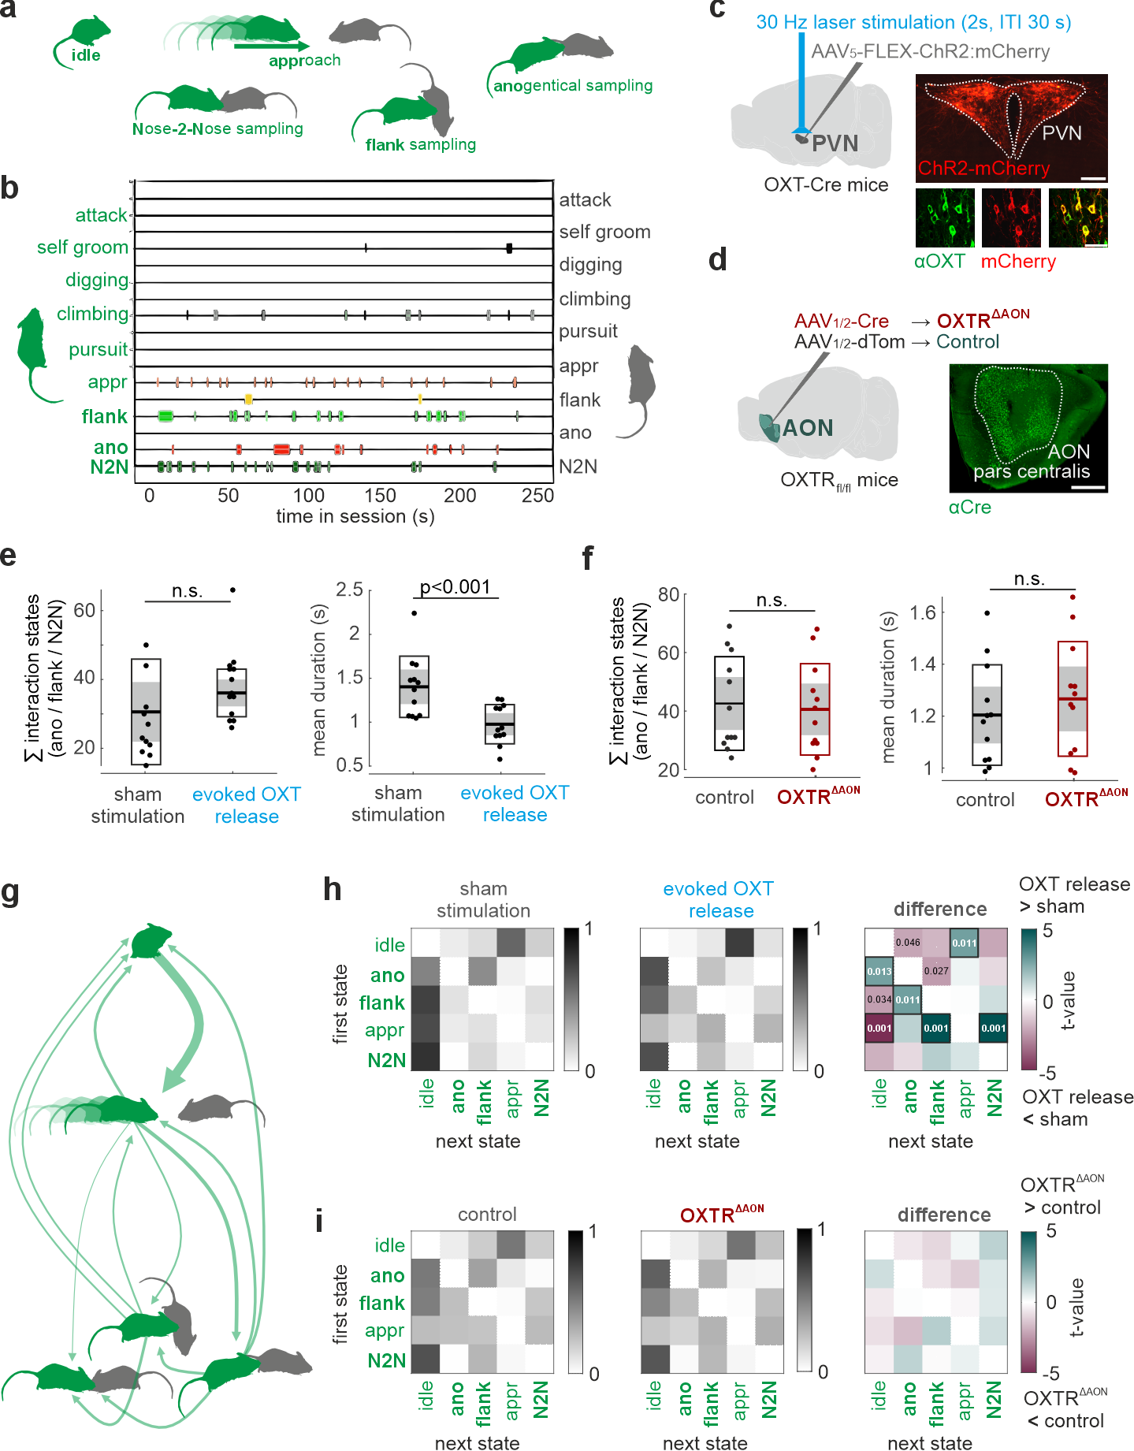
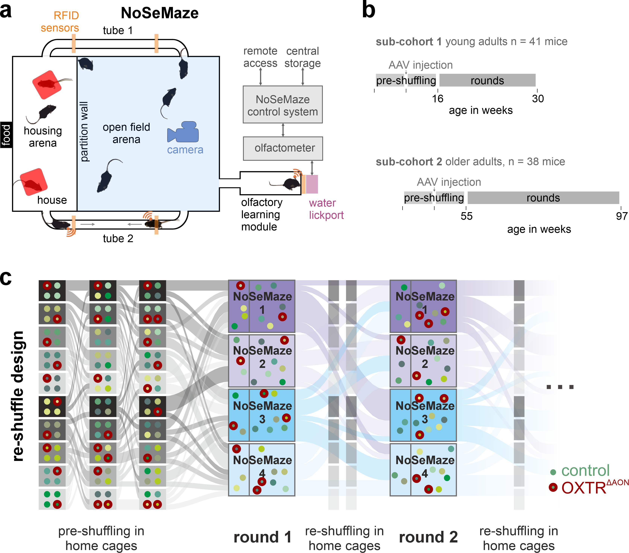
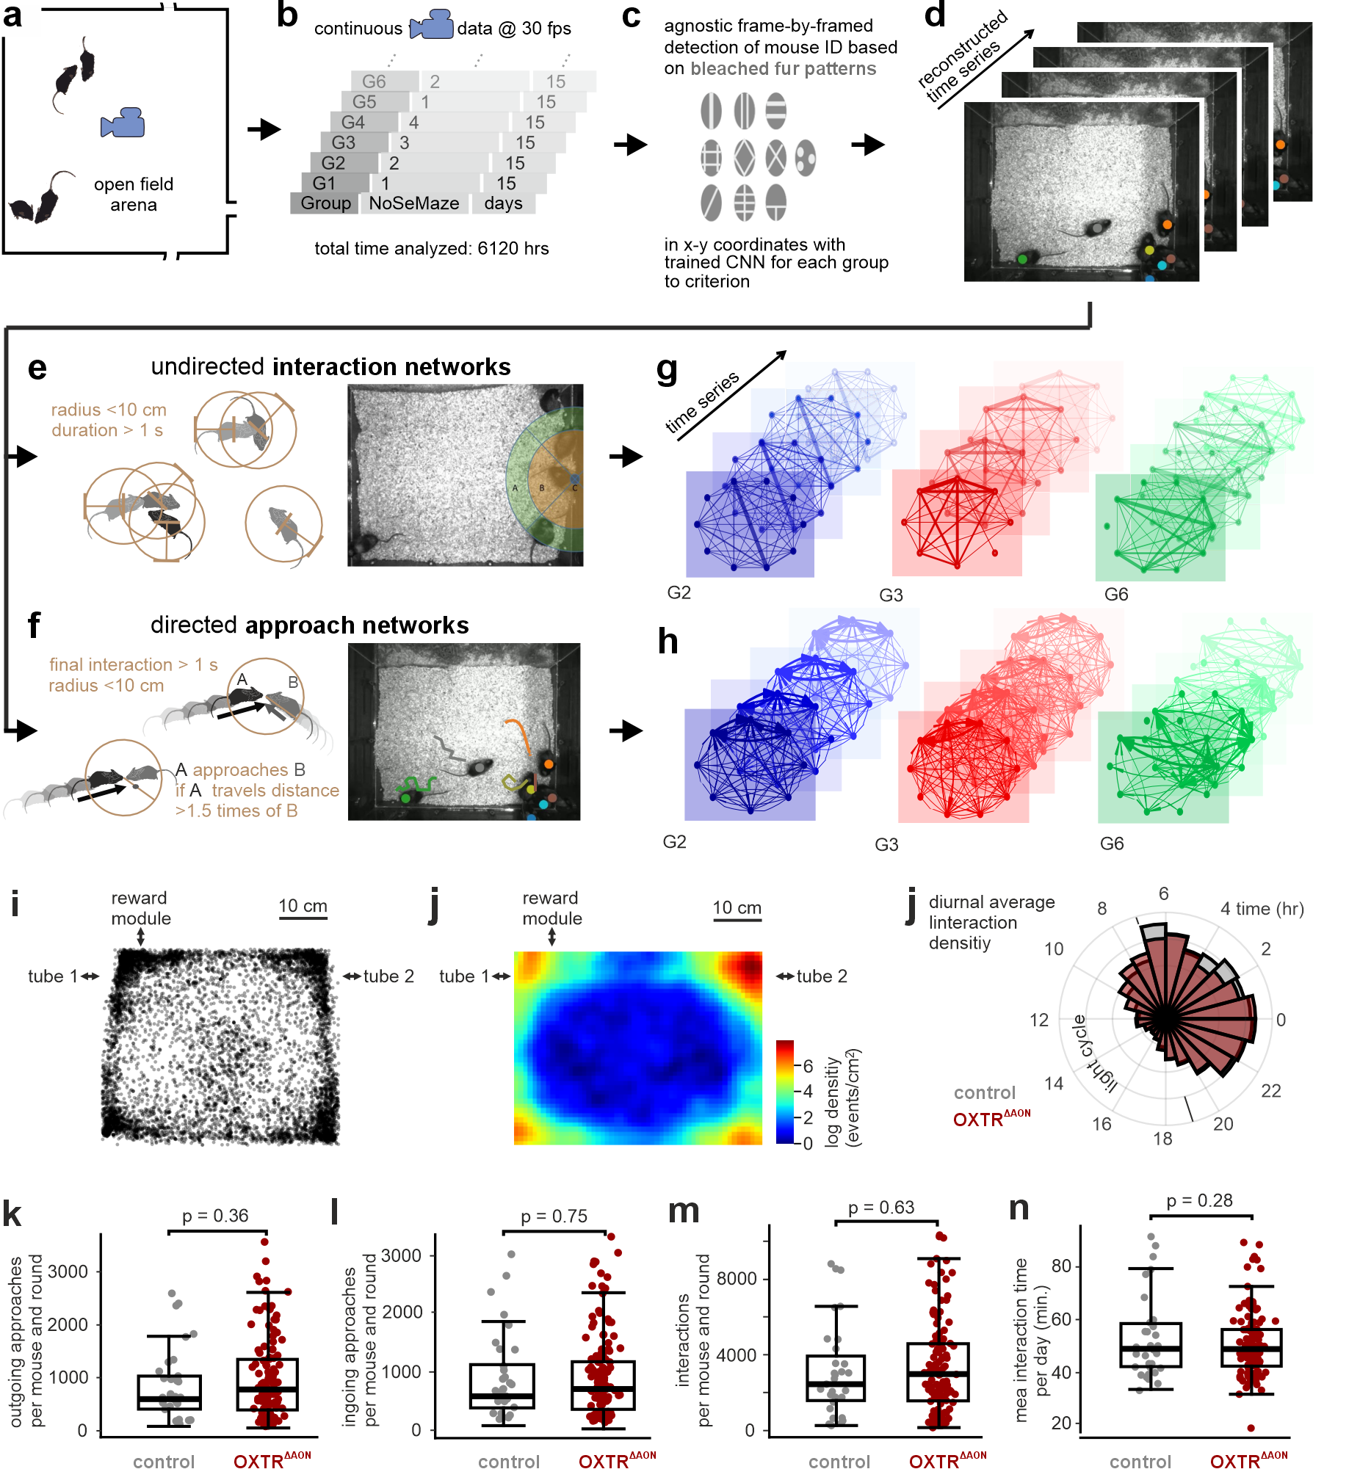
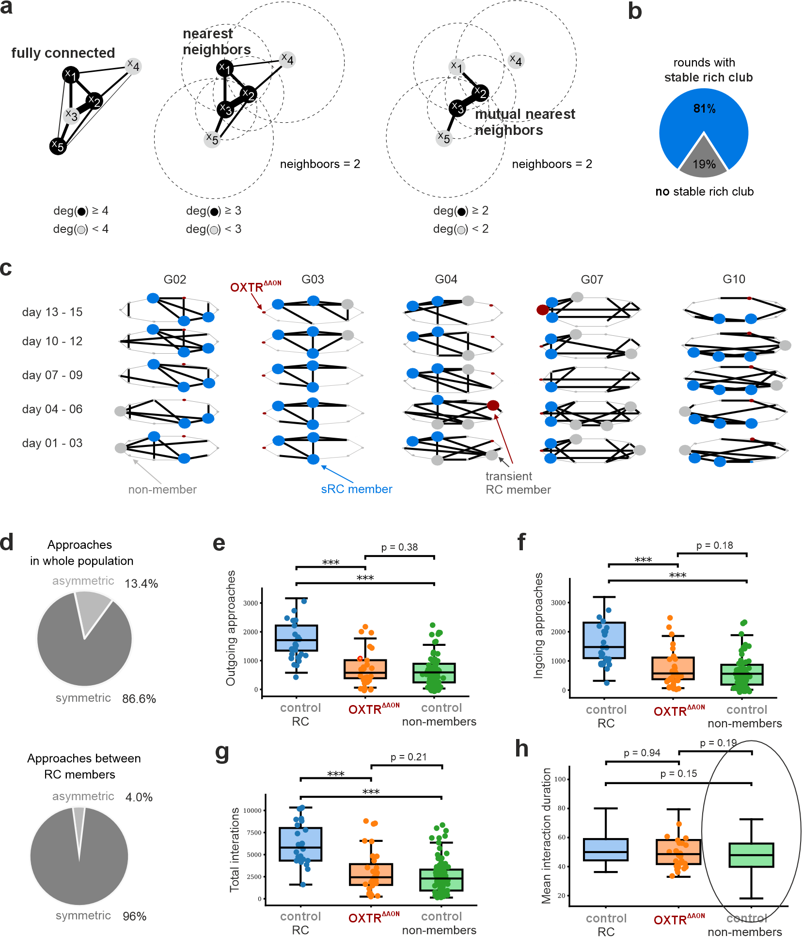
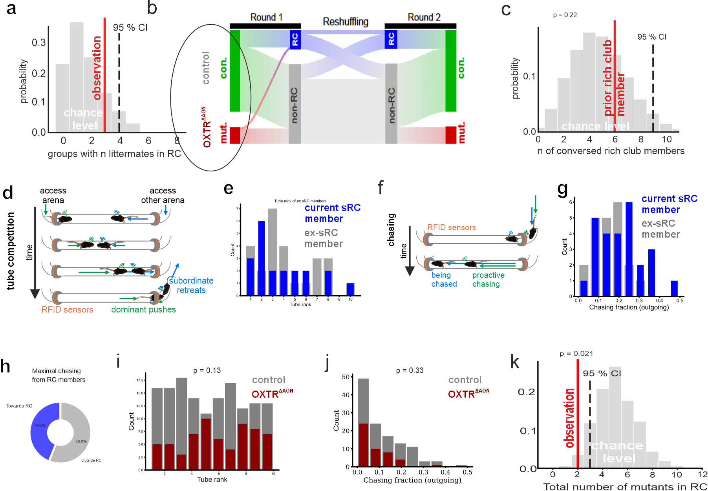
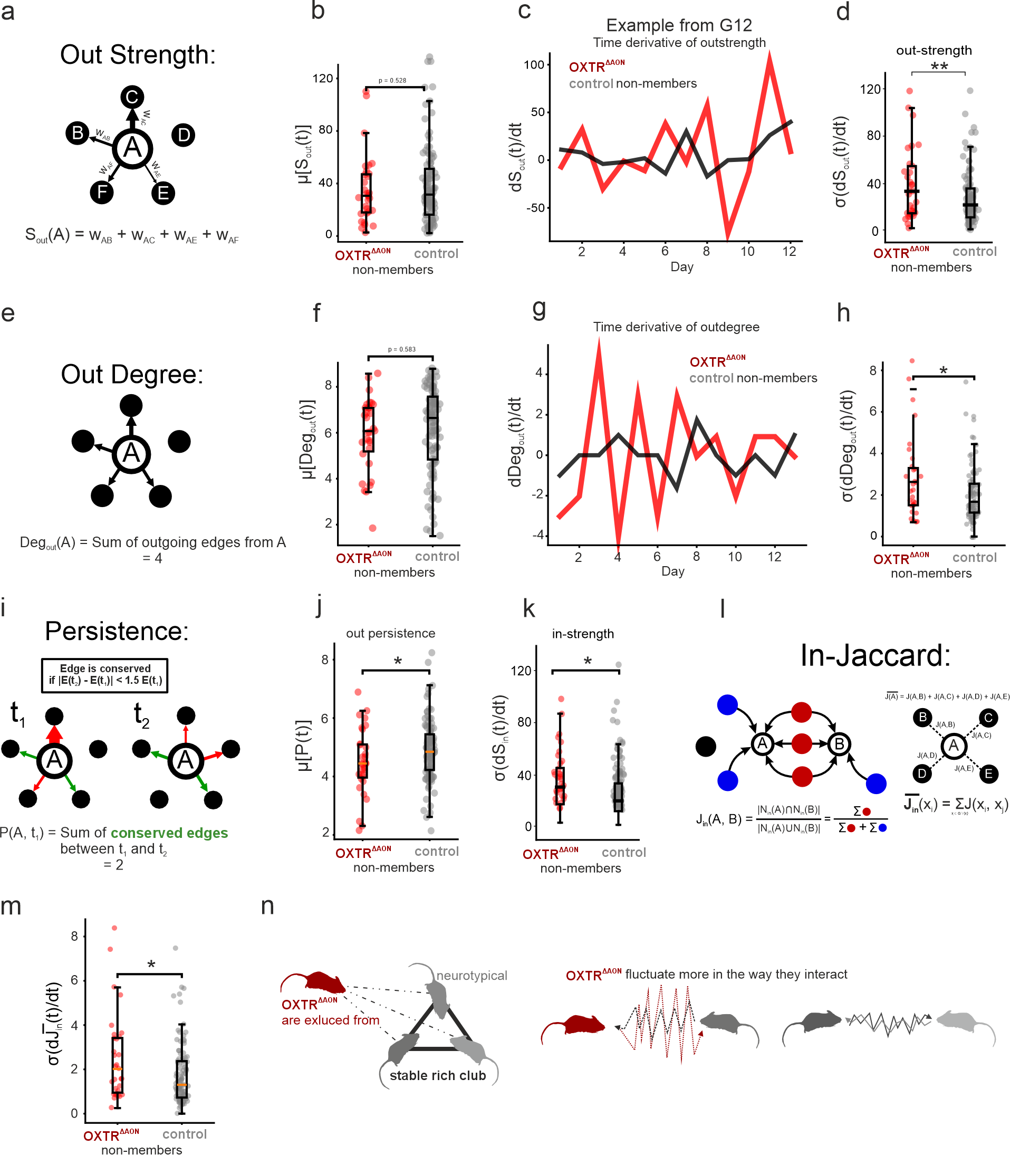
Title
Oxytocin-Enabled Social Sensory Processing States Are Critical for Higher-Order Bonding
Oxytocin Orchestrates Social Sensory States for Higher-Order Relationship Building
Social Sensory States Driven by Oxytocin Enable Complex Social Relationship Formation
Oxytocin-Dependent Sensory Processing Gates Complex Social Bond Formation
De novo formation of stable cliques in mouse societies requires oxytocin-enabled social sensory processing states

Authors
Corentin Nelias^{1,2,#}, Sarah Ghanayem^{1,2,#}, David Wolf^{1,2}, Marcel Moor¹, Max F. Scheller¹, Carla Filosa¹, Valery Grinevich², Jonathan R. Reinwald^{1,2,§}, Wolfgang Kelsch^{1,2,§,}*
¹ Dept. of Psychiatry and Psychotherapy, University Medical Center Mainz, Johannes-Gutenberg University, Untere Zahlbacher Strasse 8, 55131 Mainz, Germany
² Dept. of Psychiatry and Psychotherapy, Central Institute of Mental Health, Medical Faculty Mannheim, Heidelberg University, Square J5, 68159 Mannheim, Germany
# shared first authors, § shared last authors, * corresponding author: wokelsch@uni-mainz.de

Abstract

The ability to form stable de novo relationships in complex environments is essential for social functioning and impaired in severe psychiatric disorders including autism. Yet, the neurobiological basis enabling the formation of stable bonds in societies remains incompletely understood and limits the development of effective therapies. We therefore establish here a semi-naturalistic model of clique formation in mouse societies where individuals are tracked longitudinally from massive video data. Small stable rich clubs develop in these mouse societies. They depend on specific group configurations so that prior membership in another society or kinship does not help in the current group. These cohesive cliques tend to have high social rank and exert influence on non-members. Mimicking sparse population genetics, we find that selectively disrupting cortical oxytocin signaling—specifically involved in setting social sensory processing states—prevents mice from becoming rich club members. Despite preserved social motivation, reduced cortical oxytocin signaling resulted in fluctuating connectivity with the group, also affecting the stability how these mice were approached. Taken together, longitudinal tracking of individuals in larger mouse groups in a controlled semi-naturalistic environment reveals a neuromodulatory pathway required to enter de novo cliques of strong social cohesion. These deficits underscore the role of oxytocin in tuning sensory systems into a social cognition state, with profound implications for an individual's ability to establish stable relationships within social networks.

Introduction 928 words
Structured social networks emerge from repeated interactions, leading to preferential associations that may stabilize into enduring affiliative subgroups (Kappeler et al., 2019). Difficulties in establishing stable interpersonal relationships are a hallmark of severe mental disorders and significantly contribute to impairments in everyday functioning (Adolphs, 2009; Frith and Frith, 2006). However, the ability to form and maintain such de novo social relationships also varies substantially across individuals in the general population. Importantly, such variations in higher-order social behavior may not necessarily manifest as reduced social interest or interaction frequency. Instead, they often reflect a diminished ability to occupy and maintain functional roles within complex social networks (Holt-Lunstad et al., 2010; Kasari et al., 2011). High-functioning autism spectrum disorder (ASD), often conceptualized as an extreme expression along a continuum of typical social functioning (Kasari et al., 2011), exemplifies this dissociation in motivation and success in building de novo relationships (Dunbar and Spoors, 1995; Kasari et al., 2011). Individuals with ASD show impairments in forming stable new relationships across various contexts, even though social motivation is often preserved (Baron-Cohen, 2000; Chevallier et al., 2012; Kasari et al., 2011; Pelphrey and Carter, 2008). These challenges become particularly relevant in adulthood, when social environments become more complex and require flexible integration into novel social networks. Difficulties in meeting such demands are associated with adverse long-term psychosocial and economic outcomes (Holt-Lunstad et al., 2010; Kasari et al., 2011).
Network theory provides a powerful framework for understanding the structural underpinnings of social cohesion. It highlights the critical role of tightly connected subgroups in maintaining network resilience and integrity (Borondo et al., 2015; Centola, 2010; Dunbar and Spoors, 1995). While such structures are well documented in real-world and digital social networks (Borondo et al., 2015; Centola, 2010; Colizza et al., 2006; Dunbar and Spoors, 1995; Kasari et al., 2011), the neurobiological mechanisms that support their formation and maintenance remain poorly understood. In graph theory, highly integrated social configurations can be described as rich clubs (RC) – which is cores of nodes within the networks that are densely interconnected with each other (Colizza et al., 2006; Dunbar and Spoors, 1995). These RCs support robust social functioning and exerting significant influence over information flow, social support, and integration (Borondo et al., 2015; Colizza et al., 2006; Dong et al., 2015; Dunbar and Spoors, 1995). Identifying how individuals gain stable access to these high-value social structures may offer new insight into the subtle cognitive and neural underpinnings regulating social integration.
Across mammals, a key modulator of social cognition is oxytocin (Ferguson et al., 2000; Marlin et al., 2015; Oettl et al., 2016; Walum and Young, 2018; Wolf et al., 2024) that has led to therapeutic interest in conditions characterized by social deficits (Guastella and MacLeod, 2012; Yamasue et al., 2020). However, clinical trials of intranasal oxytocin have yielded inconsistent and often disappointing outcomes in socially complex settings (Guastella and MacLeod, 2012; Yamasue et al., 2020). This discrepancy raises the question whether our mechanistic understanding of oxytocin function is sufficient (Leng and Ludwig, 2016), particularly in the context of higher-order social behaviors. Oxytocin supports a variety of region-specific functions in the brain including social sensory processing and motivation (Ferguson et al., 2000; Marlin et al., 2015; Oettl et al., 2016; Walum and Young, 2018). In neuropsychological testing, impaired social sensory processing and recognition in the auditory, olfactory and visual domains are consistently found in ASD (Endevelt-Shapira et al., 2018; Joseph and Tanaka, 2003; Kendrick et al., 1992; Rozenkrantz et al., 2015). It is however not entirely clear how neuropsychological deficits relate to higher social cognition and functioning. Oxytocin sets the olfactory system of rodents into a state for processing of social information (Oettl et al., 2016; Wolf et al., 2024). Oxytocin receptor (OXTR) in the anterior olfactory nucleus (AON) increases top-down the signal to noise in early sensory input (Oettl et al., 2016). Mice with reduced OXTR signaling in this region (OXTR^{∆AON}) are impaired in social recognition at the neuronal and cognitive level (Wolf et al., 2024). Genetic polymorphisms influencing OXTR expression also appear to modulate human sensory processing (LoParo and Waldman, 2015; Skuse et al., 2014). It remains unclear what phenotypic consequences oxytocin’s function in sensory state setting has on higher social functioning in real life conditions. There are different scenarios. Low top-down salience may reduce social motivation for interaction and may alter sensory sampling behavior. Alternatively, motivation may be regulated by other brain centers and only increasing demands will precipitate a phenotype. In this respect, the phenotype an emergent property of increasing complexity. The latter would mean that early sensory defects produce a selective phenotype typically associated with higher cognitive functions.
Social networks are non-linear dynamical systems (Colizza et al., 2006; Dunbar and Spoors, 1995). This has several implications. Certain phenotypes may not be detectable in simple dyadic interactions but instead represent emergent properties of higher-order social networks involving multiple individuals (Dunbar and Spoors, 1995; Johnson, 2006). Emergent properties are macro-level phenomena that result from micro-level interactions among the components of a system, where the outcome cannot be inferred by summing the parts. It can therefore be informative to directly compare behavior across simple and complex social conditions. Secondly, in such networks, a change in one individual (or ‘node’) may not only alter its own behavior but also modify the responses of other nodes, leading to dynamic feedback effects (Colizza et al., 2006; Dong et al., 2015; Dunbar and Spoors, 1995). More specifically, this means that a social sensory processing impairment may remain undetected in isolated pairwise interactions, but become evident through actions and reactions of others within a dynamic social network of multiple individuals.
Given this, experimental requirements arise. Individuals need to be tracked within larger groups over longer periods to allow social subnetworks to emerge, stabilize or dissolve. Group sizes significantly shape social structure, with smaller groups (~4) often forming despotic hierarchies (Sofer et al., 2024), not found in larger groups (~10 mice) (Reinwald et al., 2025). To disentangle whether behavior comes from internalized prior experience or is context dependent on the group, varying configurations of peers should be tested. Moreover, multiple domains of social behavior should be captured to put social relations into a comprehensive perspective. Finally, inspired by natural patterns of genetic variation within populations (SELANDER, 1970), genetic manipulations should be limited to a minority of animals to ensure that neurotypical individuals continue to shape the dominant group dynamics.
To meet these requirements, we designed a non-invasive, sensor-rich platform (NoSeMaze) for mice (Reinwald et al., 2025), which monitors spontaneous social behavior of identified individuals in a larger group continuously over weeks. The sensor-rich system equipped with video and wireless ID tracking, enables automated tracking of naturalistic interactions and the assessment of social network dynamics without experimenter intervention. Leveraging the NoSeMaze, we examine the neurobiological mechanisms underlying the formation and stabilization of rich-club (RC) structures in social networks, focusing specifically on the role of oxytocin in modulating social salience and recognition. To this end, we interspersed a minority of mice carrying OXTR^{∆AON} into otherwise neurotypical groups. This design allowed us to test whether the phenotypes associated with OXTR^{∆AON} represent emergent properties of higher-order social networks.

Results
OXTR deletion in the AON does not alter brief dyadic social interaction patterns
It is not known if loss of OXT signaling in the AON affects the microstructure of self-paced dyadic same-sex interactions. We therefore probed their interaction states and transitions between them in controlled conditions that allow for high resolution mapping of these behaviors (Fig. 1a,b). We benchmarked a cohort with selective adult deletion of OXTR in the AON (OXTR^{ΔAON} with bilateral injection of AAV_{1/2}-CBA-Cre in adult male OXTR_{fl/fl} mice) and its matched controls (Fig. 1c) against a cohort of mice with optogenetics-boosted global OXT release throughout the forebrain (AAV-mediated conditional ChR2 expression in the paraventricular nucleus of male OXT-Cre mice) and sham stimulation in the same mice (Fig.1d). As hypothesized, boosted OXT release led to a tendency toward more sampling events, with significantly shorter durations (Fig. 1e), suggesting subtle facilitation of interactions. In contrast, OXTR^{ΔAON} mice did not differ from controls in the number or duration of interaction states (Fig. 1f). Boosted OXT release led to more frequent transitions from approach into sampling behaviors and a decrease of aborted interactions after approaches were initiated (Fig. 1h), consistent with enhanced social engagement. By contrast, OXTR^{ΔAON} mice showed no significant differences from matched controls in transition probabilities (Fig. 1i). Partner behavior remained unchanged across all groups (Supplementary Fig. 2), indicating no reactive effects during brief interactions.
In summary, selective deletion of OXTR in the AON did not alter dyadic social interaction behavior during brief interactions, consistent with OXT acting mainly on social cognition in this cortex. We therefore wondered what consequences the selective impairment in social cognition may have in complex and dynamic social networks.
Fig. 1

OXTR^{ΔAON} mice display quantitatively normal social activity in naturalistic group settings
To assess the social interaction dynamics in a complex naturalistic retaining control of complete tracking of individual behavior, we employed the NoSeMaze system (Reinwald et al., 2025). The NoSeMaze provides a semi-naturalistic sensor-rich environment enabling long-term, automated tracking of cognitive and social behaviors in group-housed mice without human interference (Fig. 2a). Groups of 9-10 RFID-chipped mice – each including two to four OXTR^{ΔAON} individuals interspersed among controls to mimic naturalistic sparse genetic (total of 79 male mice (XX OXTR^{ΔAON} and XX control mice)) – were monitored over continuous three week-rounds without experimenter intervention across. The cohort comprised younger adults (16–30 weeks) and older adults (55–97 weeks) to assure that phenotypes were observed across the adult lifespan (Fig. 2b). To assess which social behaviors depend on specific group configurations, mice lived in each round with different peers in the NoSeMaze (‘reshuffling’, Fig. 2b).

Fig. 2

We then established a pipeline to extract the social interaction networks of the groups of individually identified mice including interspersed OXTR^{ΔAON} mutants from the continuous video data in the open field arena in 17 rounds total Fig. 3a-b). To identify each mouse, distinct patterns had been bleached in the fur on the back before the round (Fig. 3c). We analyzed the first 15 days of each round as fur regrew and pattern identification by the trained RNN became less reliably. Before the start of the next round the fur pattern was refreshed. Approximately 6.100 hours of continuous video data entered into the social networks (Fig. 3d).
The RNN-based pipeline outputted the spatial coordinates associated to the position of each animal as a function of time. From the tracked positions, we defined and extracted two different types of social events of interest: interactions and approaches. This allowed us to represent the data as a social network. Interactions, which yielded undirected networks, were counted whenever the distance between two animals was less than 10 cm for at least 1.0 second (Fig 3e). We defined approaches by calculating the distances travelled in the 4 seconds before the interaction for both interaction partners (Fig. 3f). If the ratio of travelled distances of mouse A to mouse B exceeded 1.5, mouse A was considered the approaching one. Otherwise, no approach was counted, for example in cases where they equally approached each other. Approaches performed between each mice yielded a directed network. We obtained time series of undirected and directed networks (Fig. 3g-h, see Methods). Spatially, interactions preferentially occurred closer to the walls of the open arena (Fig. 3i) and during the active dark cycle (Fig. 3k). Notably, OXTR^{ΔAON} and control mice displayed quantitatively similar number of interactions and event durations (Fig. 3j-l) as well as number of both ingoing and outgoing approaches (Fig. 3m-n), suggesting preserved approach behavior in mice carrying OXTR^{ΔAON}. We therefore tested the hypothesis that social cognition deficits affect the building of targeted and thus consistent social relationships.
Fig. 3

Stable rich clubs emerge in social networks of group-housed mice
While some social relationships may be instable dynamic and occur by chance or are not stabilized by reciprocal behaviors, others gain stability and persist for the time a group of animals live in the same habitat. We were particularly interested here in identifying the key factors that enable the formation of such stable reciprocal cliques within larger groups.
Interaction data were analyzed across five consecutive 3-day windows per round. Given the high baseline connectivity in the networks, graphs were pruned using a mutual nearest-neighbor algorithm to isolate stable and behaviorally relevant substructures (Fig. 4a; Supplementary Fig. X). In most cohorts (81%), we observed the emergence of stable, densely interconnected subnetworks composed of high-degree nodes. These structures (Fig. 4b–c) represent rich clubs (RC) [14, 17]. RCs that persisted across at least 4 out of 5 3-day-graphs were considered stable rich clubs (sRC). Notably, sRC were robustly identifiable in both undirected interaction and directed approach networks. Statistical modeling confirmed that such persistence was highly unlikely to occur by chance (p < 10⁻⁷ for pairs; p < 10⁻⁹ for triads), indicating genuine social structure. sRC emerged in all 10 rounds with older adults (Fig. 5c, Supplementary Fig. x), while sRC were observed with younger adults in 4 out of 7 rounds (Supplementary Fig. x), potentially suggesting that age favors the formation of such cliques.
sRC members displayed distinct interaction behaviors. Compared to non-members, they engaged in more interactions and approaches (Fig. 4d–f), although approach duration did not differ (Fig. 4g). Notably, OXTR^{ΔAON} mice behaved quantitatively similarly as non-members in these measures (Fig. 4d–g). sRC members also exhibited greater reciprocity: 96.0% of their approaches were reciprocal, compared to 67.7% in the general population (Fig. 4h). Thus, sRC form in most of the groups in the NoSeMaze and can be identified both from undirected interaction graphs and directional approach networks.
Fig. 4

Rich club membership emerges from group-specific dynamics Stable RC membership came with differences in other social behaviors. In social rank networks derived from dyadic competitions in the tubes of the NoSeMaze (Fig. 5a, c.f. Reinwald et al., 2025), sRC members tended to occupy higher positions in the social hierarchy (Fig. 5b). The distribution of social ranks however had a large variance among sRC members, suggesting that high social rank might promote, but does not guarantee sRC membership. We also tested for proactive chasing of others through the tubes (Fig. 5c). sRC members initiated more chases than non-members (Fig. 5d). Notably, sRC members initiated on average 44% of their chasings towards other sRC members (fig. 5h), which is significantly higher than the ~25% expected by random chance (p-value 0.0014).
We next tested predictions on the nature of sRC. Firstly, sRC may emerge from the interplay among specific individuals. Thus, shared upbringing may be a factor promoting shared sRC membership in the adult also in larger groups. We took advantage that we had multiple siblings per group. However, kinship (Fig. 2g) did not increase the likelihood to become a member in a sRC above random chance (Fig. 2h). Secondly, prior membership experience might promote sRC membership in the next round. Alternatively, sRC membership might be a result of the specific group dynamics. To test this, we took advantage of the reshuffling of the mice that configured different group compositions in consecutive rounds (Fig. 5i, cf. Fig. 2b). Among mice participating in multiple NoSeMaze rounds, the probability of re-entering a sRC did not exceed chance (Fig. 5j), suggesting that sRC membership is not an intrinsic individual attribute, but instead emerges de novo from the specific social dynamics within each group. This contrasts with the two other social behaviors, social rank and proactive chasing, that become internalized in individuals and are largely maintained across different group configurations (Reinwald et al, 2025). The fact that the distribution of social rank and chasing propensity of mice that were once sRC members in one group but not in another did not change significantly suggests that a somewhat high rank might be a necessary but not sufficient condition to enter the sRC (Fig. 5e and 5g). Notably, OXTR^{ΔAON} and neurotypical mice differed neither in their mean hierarchy (Fig. 5i) nor in their expression of chasing behavior (Fig. 5j).
In summary, most groups in the NoSeMaze form stable interconnected social structures that can be described as RCs. We found that mice in the RCs were significantly more active, engaged in more reciprocal interactions, and initiated more chasings than non-members. Owing to the fact that family relationships did not significantly influence rich club formation, and that most mice that entered the club did not integrate it again with new peers, we conclude that sRC formation is an emergent property reflecting the dynamic nature of the social interaction within each group.
OXTR^{ΔAON} mice fail to integrate into stable rich clubs
Since the formation of rich clubs in colonies appears to be a consequence of higher-order social interactions, a crucial question is whether OXTR^{ΔAON} mice enter them or not. OXTR^{ΔAON} mice have been shown to suffer from social cognition deficits (CITE). While these deficiencies did not lead to significant differences in the way mice partake in dyadic interactions (cf. Fig. 1 and 5h-i), it is very well possible that OXTR^{ΔAON} mice lack the capacity to engage in complex stable social relationships. To answer this question, we compared the number of OXTR^{ΔAON} mice that were able to enter the rich club to the one that would be expected by random chance using a bootstrap approach. The results (Fig. 5n) show that OXTR^{ΔAON} mice are significantly less likely to enter the sRC than control mice. This impairment was observed both in younger and older adult (see Supplementary Fig. X). In summary, OXT signaling in the AON plays a crucial role in the formation of social cliques that form de novo among mice in larger groups (cf. Fgi. 5i).
Fig. 5

Unstable network dynamics in OXTR^{ΔAON} mice hinder social integration
Although OXTR^{ΔAON} and control mice showed no differences in average measures of interaction time, approach frequency or social rank, OXTR^{ΔAON} mice failed to enter sRCs. To probe its role in complex social learning, we analyzed how their social network connections behave as a function of time. Stronger fluctuation levels may explain the mutants’ inability to engage in stable relationships with others. Specifically, we examined fluctuations in directional approach networks, using the time derivatives of key graph metrics to assess instability. To avoid confounds from current RC membership, comparisons were made between OXTR^{ΔAON} mice and neurotypical non-members, the latter of whom could nonetheless be sRC members in other rounds. We thereby isolated latent deficits specific to the OXTR^{ΔAON} phenotype.
We first focused on the stability of outgoing connections of mice carrying OXTR^{ΔAON}. Indeed, the outgoing strength (Fig. 6a–b) fluctuated significantly more in OXTR^{ΔAON} mice (Fig. 6c–d). Outgoing strength measures the total number of approaches performed by a mouse on the day independent of how many different mice were approached, thus reflecting also general social motivation (cf. Fig. 6a). In contrast, the out-degree measures the normalized intensity of approaches to other mice and thus is largely independent of the total number of approaches performed that day (Fig. 6e). Instability was also observed in out-degree, (Fig. 6f–h), supporting that while OXTR^{ΔAON} mice are socially active, their partner selection is more erratic.
To assess fluctuation levels in specific connections, we drew inspiration from the field of temporal graphs and propose a measurement that we call ‘persistence’ to study how connections between two partners are preserved in time. We define persistence as the number of preserved edges over time (Fig 6i). Indeed, OXTR^{ΔAON} mice form less persistent edges than neurotypical non-sRC-members (Fig 6j).
We next asked whether this instability also affects the way OXTR^{ΔAON} mice were perceived within the group. Fluctuations in ingoing strength were moderately higher in OXTR^{ΔAON} mice (Fig. 6k). A similar trend was observed for in-degree (Supplementary Fig. X). We therefore assessed how OXTR^{ΔAON} mice were socially embedded in the group by analyzing the time derivative of the in-Jaccard index, a network measure quantifying graph similarity that is the overlap in social partners over time (Fig. 6l). Indeed, this index fluctuated more strongly for OXTR^{ΔAON} mice (Fig. 6m), suggesting that their role within the group structure was less stable than that of controls. Together, these findings reveal that mice carrying OXTR^{ΔAON} not only initiate relationships less consistently, but also evoke more variable responses from peers (Fig. 6n).

Fig. 6
Notes: add blinding in the methods (for the OXTR-KO)

Discussion 1254 words
Summary
This study reveals that mice living in semi-naturalistic social groups form temporally stable and reciprocally connected cliques, so-called ‘stable rich clubs’ (sRC), which shape group structure and indicate high social integration. These tightly connected hubs were robust and persistent over time, reflecting genuine and selective affiliative bonds rather than transient proximity. As such, sRC represent emergent properties of higher-order social networks. Mice with a targeted deletion of the oxytocin receptor in the AON (OXTR^{ΔAON}), embedded within predominantly neurotypical groups, failed to integrate into these sRC with normal levels of social activity in both dyadic and group contexts. This reveals that state modulation of social sensory processing becomes relevant in complex social situations when structured higher-order interactions come into play.
Stable rich club
Densely connected hubs such as rich clubs represent a fundamental component of social network organization in both humans and animals (Colizza et al., 2006; Dong et al., 2015; Dunbar and Spoors, 1995). These structures promote resilience, cohesion, and efficient information flow. In humans, rich club members often hold positions of influence and exert strong effects on network dynamics (Centola, 2010; Dong et al., 2015; Dunbar and Spoors, 1995). Consistent with this, sRC members in our study tended to occupy higher ranks and displayed broad chasing behavior beyond their immediate cliques, suggesting similarly central and influential roles within the group. Interestingly, older mice were more likely than younger ones to form sRC, potentially reflecting age-related differences in consistent social relations. We focused specifically on sRC, defined as cliques preserved over at least 80% of the experiment's duration. This approach excluded transient structures that may form by chance or fail to stabilize due to shifting affiliative focus.
sRC features
Social positions may be driven by intra-individual variables internalized from prior social experiences, while specific context variables in particular the specific group composition play less of a role. This is true in the NoSeMaze for social rank and expression of chasing behavior that are both predominently determined by intra-individual variables robust to reshuffling of group compositions (Reinwald et al., 2025). In contrast, sRC membership in one round did not significantly increase the chance to be in a sRC upon reshuffling of groups. Thus, sRC form de novo, suggesting dynamic learning in each group. Consistently, also kinship did not increase the likelihood of being in a clique together. This suggests that clique formation is not driven by fixed individual characteristic traits, but emerges anew from the specific interactions and configurations within each group. The difference between internalized social status and the ability to build novel social relationships also parallels human behavior (Borondo et al., 2015; Centola, 2010; Colizza et al., 2006; Dunbar and Spoors, 1995), where status may facilitate but does not guarantee the ability to form stable contacts.
Mutants and their deficits
Mice carrying OXTR^{ΔAON} provide here further mechanistic insight in the relation between sRC membership, social processing states and OXT function. OXTR activation in the AON sets in a state for social sensory processing through its top-down increase in signal-to-noise in the olfactory bulb (Oettl et al., 2016), then spreading throughout the brain. The consequences of impaired state induction in mice carrying OXTR^{ΔAON} were however surprisingly selective in a complex social environment. They kept normal rates of social interactions. Also, in more detailed analyses of olfactory sampling patterns, OXTR^{ΔAON} mice were normal. Together suggesting that OXT in the sensory cortex is not involved in motivation to interact or sample others. However, mice carrying were markedly impaired in forming stable connections in complex social environments. One may have expected that early sensory impairments through OXTR^{ΔAON} affect typically more basic behaviors, while higher social functions like achieving stable connectedness in social networks is a process regulated by higher brain regions. Therefore, these observations support a non-hierarchical conception of social brain functions where selective higher social cognitive phenotypes are not necessarily hinting necessarily on localization in of the original site of impairment in higher brain regions.
Prior studies have shown that OXTR^{ΔAON} mice exhibit selective impairments in social recognition despite intact non-social olfactory learning in standard assays (Oettl et al., 2016). We confirmed the latter in the NoSeMaze, where OXTR^{ΔAON} mice performed comparably to controls in non-social olfactory tasks (see Supplementary Fig. X). Fluctuations of the mutants
Temporal instability in the approach behavior of OXTR^{ΔAON} mice offers a potential mechanistic explanation for their failure to integrate into stable cliques. While overall social activity was preserved, these mice showed marked day-to-day fluctuations in the strength and consistency of their outgoing connections, as well as in the stability of responses they received from others. Network metrics such as out-degree, out-strength, and persistence revealed more erratic and inconsistent patterns of affiliative targeting compared to both rich club members and neurotypical non-members. These instabilities likely reflect deficits in social memory. Following social interactions, this oxytocin-induced state enables plasticity producing reinforced and better differentiated representations of familiar mice in the olfactory cortices (Wolf et al., 2024). This learning of OXTR^{ΔAON} mice is selectively impaired for social recognition, asPrior studies have shown that OXTR^{ΔAON} mice exhibit selective impairments in social recognition despite intact non-social olfactory discrimination learning is intact in standard assays (Oettl et al., 2016). We and as confirmed the latternow in the NoSeMaze , where OXTR^{ΔAON} mice performed comparably to controls in non-social olfactory tasks (see Supplementary Fig. X). Notably, OXTR deletion occurred only in adulthood, after mice had already internalized their social status (Reinwald et al., 2025). However, the de novo formation of sRC requires continuous learning. The deficit from OXTR^{ΔAON} in joining sRC supports that the social sensory state setting actions of oxytocin are particularly relevant in such dynamic situations. These findings underscore the continued role of adult oxytocin signaling in maintaining coherent social targeting and the formation of new social bonds.
Given the targeted deletion in the AON, a region implicated in early sensory integration and individual recognition, this aligns with prior evidence that oxytocin modulates sensory cortices toward social stimuli (Oettl et al., 2016; Wolf et al., 2024). Importantly, these temporal fluctuations also had network-level consequences: neurotypical peers also interacted less consistently with OXTR^{ΔAON} mice, leading to reduced bidirectional stability. This reciprocal disorganization highlights how dynamic social networks can amplify individual-level deficits, consistent with models of emergent properties of social behavior (Centola, 2010; Dong et al., 2015; Dunbar and Spoors, 1995; Freund et al., 2013; Johnson, 2006). Notably, OXTR deletion occurred only in adulthood, after social rank and internalized status had already stabilized (Reinwald et al., 2025), indicating that the observed disruptions stem from impaired dynamic, reciprocal social learning rather than developmental alterations. These findings underscore the continued role of adult oxytocin signaling in maintaining coherent social targeting and the formation of new social bonds.
Relation to ASD
This specific cognitive profile mirrors patterns observed in high-functioning autism spectrum disorder (ASD). ASD represents the extreme tail of a continuum in the capacity to form stable social connections in the general population (Baron-Cohen, 2000). Individuals with ASD may engage in social interactions but often struggle to develop deep, reciprocal relationships in society (Howlin et al., 2004; Kasari et al., 2011). Many function well in rigid, structured environments but have difficulties with flexible, self-directed social contexts, particularly in forming friendships (Chan et al., 2023; Howlin et al., 2004; Kasari et al., 2011). These difficulties typically become apparent only with increasing levels of social complexity, and can affect both personal and professional outcomes while growing up (Chan et al., 2023; Holt-Lunstad et al., 2010; Howlin et al., 2004; Kasari et al., 2011). Similarly, OXTR^{ΔAON} mice did not exhibit reduced social interest, but failed to stabilize their affiliative choices within complex group settings. This resulted in erratic social targeting, which in turn led to less consistent reciprocal approaches from peers. Our findings therefore suggest that the impairment in OXTR^{ΔAON} mice is not just intrinsic, but is amplified through the dynamic nature of social networks, in which unpredictability can provoke social withdrawal from others. The experimental design, in which a minority of cognitively impaired individuals was embedded within predominantly neurotypical groups, mimicked the sparse patterns of genetic variation commonly found in natural populations and was essential for revealing these network-level amplification effects.
Treatment implications and things to do in futureOur findings offer a possible explanation for the inconsistent effects of intranasal oxytocin in clinical populations: the neuromodulator may not broadly enhance sociability but instead facilitates the formation and maintenance of specific, cognitively demanding social connections. Such effects are likely context-dependent and may only manifest under conditions that require real-time social inference, partner differentiation, or flexible adaptation to shifting group structures. To capture such subtle phenotypes, we used the NoSeMaze platform, a sensor-rich, non-invasive tracking system capable of continuous behavioral monitoring in freely moving social groups. Conclusion
In sum, tracking longitudinally the collective behavior of individuals in the NoSeMaze allowed for identification non-linear affiliative dynamics with unpreceded precision. The naturalistic, yet controlled study reveals the emergent properties of social behavior and links molecular and circuit-level perturbations to supra-individual dynamics. We thereby found that state setting in sensory procession by oxytocin is essential for the stable formation of affiliative cliques within complex social networks. These cliques emerge not from fixed traits or prior experience but from dynamic interactions among individuals. In OXTR^{ΔAON} mice, fluctuations in partner targeting and reduced social predictability undermine the formation of stable, reciprocal relationships, despite preserved overall social activity. These findings help bridge the gap between circuit-level mechanisms and social network organization, offering a framework for the neural basis of social integration and its disruption in psychiatric conditions. They also highlight how emergent properties of social structure can reveal latent deficits in social cognition that only emerge with increasing complexity of the social environment.

References
Adolphs, R., 2009. The social brain: neural basis of social knowledge. Annu. Rev. Psychol. 60, 693–716. https://doi.org/10.1146/annurev.psych.60.110707.163514
Baron-Cohen, S., 2000. Theory of mind and autism: A review, in: International Review of Research in Mental Retardation, Autism. Academic Press, pp. 169–184. https://doi.org/10.1016/S0074-7750(00)80010-5
Borondo, J., Morales, A.J., Benito, R.M., Losada, J.C., 2015. Multiple leaders on a multilayer social media. Chaos Solitons Fractals, Multiplex Networks: Structure, Dynamics and Applications 72, 90–98. https://doi.org/10.1016/j.chaos.2014.12.023
Centola, D., 2010. The spread of behavior in an online social network experiment. Science 329, 1194–1197. https://doi.org/10.1126/science.1185231
Chan, D.V., Doran, J.D., Galobardi, O.D., 2023. Beyond Friendship: The Spectrum of Social Participation of Autistic Adults. J. Autism Dev. Disord. 53, 424–437. https://doi.org/10.1007/s10803-022-05441-1
Chevallier, C., Kohls, G., Troiani, V., Brodkin, E.S., Schultz, R.T., 2012. The social motivation theory of autism. Trends Cogn. Sci. 16, 231–239. https://doi.org/10.1016/j.tics.2012.02.007
Colizza, V., Flammini, A., Serrano, M.A., Vespignani, A., 2006. Detecting rich-club ordering in complex networks. Nat. Phys. 2, 110–115. https://doi.org/10.1038/nphys209
Dong, Y., Tang, J., Chawla, N.V., Lou, T., Yang, Y., Wang, B., 2015. Inferring social status and rich club effects in enterprise communication networks. PloS One 10, e0119446. https://doi.org/10.1371/journal.pone.0119446
Dunbar, R.I., Spoors, M., 1995. Social networks, support cliques, and kinship. Hum. Nat. Hawthorne N 6, 273–290. https://doi.org/10.1007/BF02734142
Endevelt-Shapira, Y., Perl, O., Ravia, A., Amir, D., Eisen, A., Bezalel, V., Rozenkrantz, L., Mishor, E., Pinchover, L., Soroka, T., Honigstein, D., Sobel, N., 2018. Altered responses to social chemosignals in autism spectrum disorder. Nat. Neurosci. 21, 111–119. https://doi.org/10.1038/s41593-017-0024-x
Ferguson, J.N., Young, L.J., Hearn, E.F., Matzuk, M.M., Insel, T.R., Winslow, J.T., 2000. Social amnesia in mice lacking the oxytocin gene. Nat. Genet. 25, 284–288. https://doi.org/10.1038/77040
Freund, J., Brandmaier, A.M., Lewejohann, L., Kirste, I., Kritzler, M., Krüger, A., Sachser, N., Lindenberger, U., Kempermann, G., 2013. Emergence of individuality in genetically identical mice. Science 340, 756–759. https://doi.org/10.1126/science.1235294
Frith, C.D., Frith, U., 2006. The neural basis of mentalizing. Neuron 50, 531–534. https://doi.org/10.1016/j.neuron.2006.05.001
Guastella, A.J., MacLeod, C., 2012. A critical review of the influence of oxytocin nasal spray on social cognition in humans: evidence and future directions. Horm. Behav. 61, 410–418. https://doi.org/10.1016/j.yhbeh.2012.01.002
Holt-Lunstad, J., Smith, T.B., Layton, J.B., 2010. Social Relationships and Mortality Risk: A Meta-analytic Review. PLOS Med. 7, e1000316. https://doi.org/10.1371/journal.pmed.1000316
Howlin, P., Goode, S., Hutton, J., Rutter, M., 2004. Adult outcome for children with autism. J. Child Psychol. Psychiatry 45, 212–229. https://doi.org/10.1111/j.1469-7610.2004.00215.x
Johnson, C.W., 2006. What are emergent properties and how do they affect the engineering of complex systems? Reliab. Eng. Syst. Saf., Complexity in Design and Engineering 91, 1475–1481. https://doi.org/10.1016/j.ress.2006.01.008
Joseph, R.M., Tanaka, J., 2003. Holistic and part-based face recognition in children with autism. J. Child Psychol. Psychiatry 44, 529–542. https://doi.org/10.1111/1469-7610.00142
Kappeler, P.M., Clutton-Brock, T., Shultz, S., Lukas, D., 2019. Social complexity: patterns, processes, and evolution. Behav. Ecol. Sociobiol. 73, 5. https://doi.org/10.1007/s00265-018-2613-4
Kasari, C., Locke, J., Gulsrud, A., Rotheram-Fuller, E., 2011. Social networks and friendships at school: comparing children with and without ASD. J. Autism Dev. Disord. 41, 533–544. https://doi.org/10.1007/s10803-010-1076-x
Kendrick, K.M., Lévy, F., Keverne, E.B., 1992. Changes in the sensory processing of olfactory signals induced by birth in sheep. Science 256, 833–836. https://doi.org/10.1126/science.1589766
Leng, G., Ludwig, M., 2016. Intranasal Oxytocin: Myths and Delusions. Biol. Psychiatry 79, 243–250. https://doi.org/10.1016/j.biopsych.2015.05.003
LoParo, D., Waldman, I.D., 2015. The oxytocin receptor gene (OXTR) is associated with autism spectrum disorder: a meta-analysis. Mol. Psychiatry 20, 640–646. https://doi.org/10.1038/mp.2014.77
Marlin, B.J., Mitre, M., D’amour, J.A., Chao, M.V., Froemke, R.C., 2015. Oxytocin enables maternal behaviour by balancing cortical inhibition. Nature 520, 499–504. https://doi.org/10.1038/nature14402
Oettl, L.-L., Ravi, N., Schneider, M., Scheller, M.F., Schneider, P., Mitre, M., da Silva Gouveia, M., Froemke, R.C., Chao, M.V., Young, W.S., Meyer-Lindenberg, A., Grinevich, V., Shusterman, R., Kelsch, W., 2016. Oxytocin Enhances Social Recognition by Modulating Cortical Control of Early Olfactory Processing. Neuron 90, 609–621. https://doi.org/10.1016/j.neuron.2016.03.033
Pelphrey, K.A., Carter, E.J., 2008. Brain mechanisms for social perception: lessons from autism and typical development. Ann. N. Y. Acad. Sci. 1145, 283–299. https://doi.org/10.1196/annals.1416.007
Rozenkrantz, L., Zachor, D., Heller, I., Plotkin, A., Weissbrod, A., Snitz, K., Secundo, L., Sobel, N., 2015. A Mechanistic Link between Olfaction and Autism Spectrum Disorder. Curr. Biol. CB 25, 1904–1910. https://doi.org/10.1016/j.cub.2015.05.048
SELANDER, R.K., 1970. Behavior and Genetic Variation in Natural Populations. Am. Zool. 10, 53–66. https://doi.org/10.1093/icb/10.1.53
Skuse, D.H., Lori, A., Cubells, J.F., Lee, I., Conneely, K.N., Puura, K., Lehtimäki, T., Binder, E.B., Young, L.J., 2014. Common polymorphism in the oxytocin receptor gene (OXTR) is associated with human social recognition skills. Proc. Natl. Acad. Sci. U. S. A. 111, 1987–1992. https://doi.org/10.1073/pnas.1302985111
Sofer, Y., Zilkha, N., Gimpel, E., Wagner, S., Chuartzman, S.G., Kimchi, T., 2024. Sexually dimorphic oxytocin circuits drive intragroup social conflict and aggression in wild house mice. Nat. Neurosci. 27, 1565–1573. https://doi.org/10.1038/s41593-024-01685-5
Walum, H., Young, L.J., 2018. The neural mechanisms and circuitry of the pair bond. Nat. Rev. Neurosci. 19, 643–654. https://doi.org/10.1038/s41583-018-0072-6
Wolf, D., Hartig, R., Zhuo, Y., Scheller, M.F., Articus, M., Moor, M., Grinevich, V., Linster, C., Russo, E., Weber-Fahr, W., Reinwald, J.R., Kelsch, W., 2024. Oxytocin induces the formation of distinctive cortical representations and cognitions biased toward familiar mice. Nat. Commun. 15, 6274. https://doi.org/10.1038/s41467-024-50113-6
Yamasue, H., Okada, T., Munesue, T., Kuroda, M., Fujioka, T., Uno, Y., Matsumoto, K., Kuwabara, H., Mori, D., Okamoto, Y., Yoshimura, Y., Kawakubo, Y., Arioka, Y., Kojima, M., Yuhi, T., Owada, K., Yassin, W., Kushima, I., Benner, S., Ogawa, N., Eriguchi, Y., Kawano, N., Uemura, Y., Yamamoto, M., Kano, Y., Kasai, K., Higashida, H., Ozaki, N., Kosaka, H., 2020. Effect of intranasal oxytocin on the core social symptoms of autism spectrum disorder: a randomized clinical trial. Mol. Psychiatry 25, 1849–1858. https://doi.org/10.1038/s41380-018-0097-2

